**Code:**

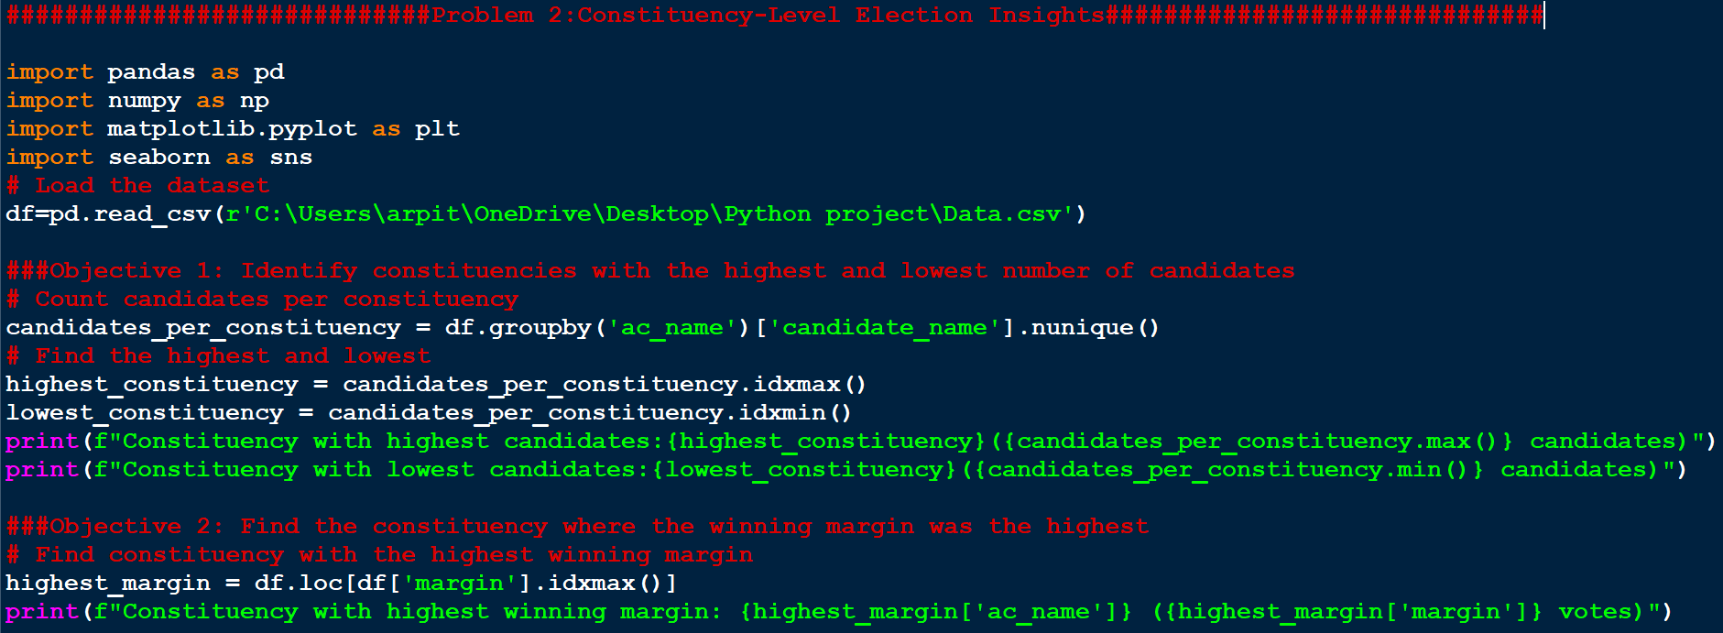

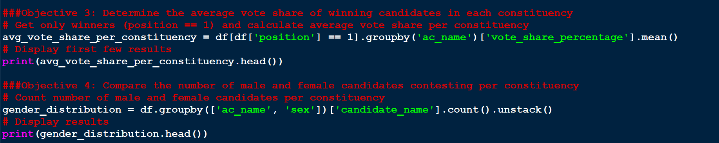

#############################Problem 2:Constituency-Level Election Insights##############################

import pandas as pd

import numpy as np

import matplotlib.pyplot as plt

import seaborn as sns

# Load the dataset

df=pd.read_csv(r'C:\Users\arpit\OneDrive\Desktop\Python project\Data.csv')

###Objective 1: Identify constituencies with the highest and lowest number of candidates

# Count candidates per constituency

candidates_per_constituency = df.groupby('ac_name')['candidate_name'].nunique()

# Find the highest and lowest

highest_constituency = candidates_per_constituency.idxmax()

lowest_constituency = candidates_per_constituency.idxmin()

print(f"Constituency with highest candidates:{highest_constituency}({candidates_per_constituency.max()} candidates)")

print(f"Constituency with lowest candidates:{lowest_constituency}({candidates_per_constituency.min()} candidates)")

###Objective 2: Find the constituency where the winning margin was the highest

# Find constituency with the highest winning margin

highest_margin = df.loc[df['margin'].idxmax()]

print(f"Constituency with highest winning margin: {highest_margin['ac_name']} ({highest_margin['margin']} votes)")

###Objective 3: Determine the average vote share of winning candidates in each constituency

# Get only winners (position == 1) and calculate average vote share per constituency

avg_vote_share_per_constituency = df[df['position'] == 1].groupby('ac_name')['vote_share_percentage'].mean()

# Display first few results

print(avg_vote_share_per_constituency.head())

###Objective 4: Compare the number of male and female candidates contesting per constituency

# Count number of male and female candidates per constituency

gender_distribution = df.groupby(['ac_name', 'sex'])['candidate_name'].count().unstack()

# Display results

print(gender_distribution.head())

**Output:**

